INTRODUCTION TO THE 5ESS SWITCH
This lesson will introduce the 5ESS-2000 Switch. The 5ESS-2000 Switch has 3 major types of equipment modules: the SM/SM-2000 (Switching Module), CM (Communication Module), and the AM (Administrative Module). Each module performs assigned functions that contribute to the total operation of the 5ESS-2000 Switch.
- BASIC CHARACTERISTICS OF THE 5ESS SWITCH
The 5ESS-2000 Switch is a digital exchange that can serve as a local (lines), toll (trunks), tandem (lines and trunks), OSPS (Operator Service Position System) or international gateway exchange, depending on the type of switch. It can serve a small community with fewer than 100 subscribers or a large metropolitan area serving more than 100,000 subscribers.
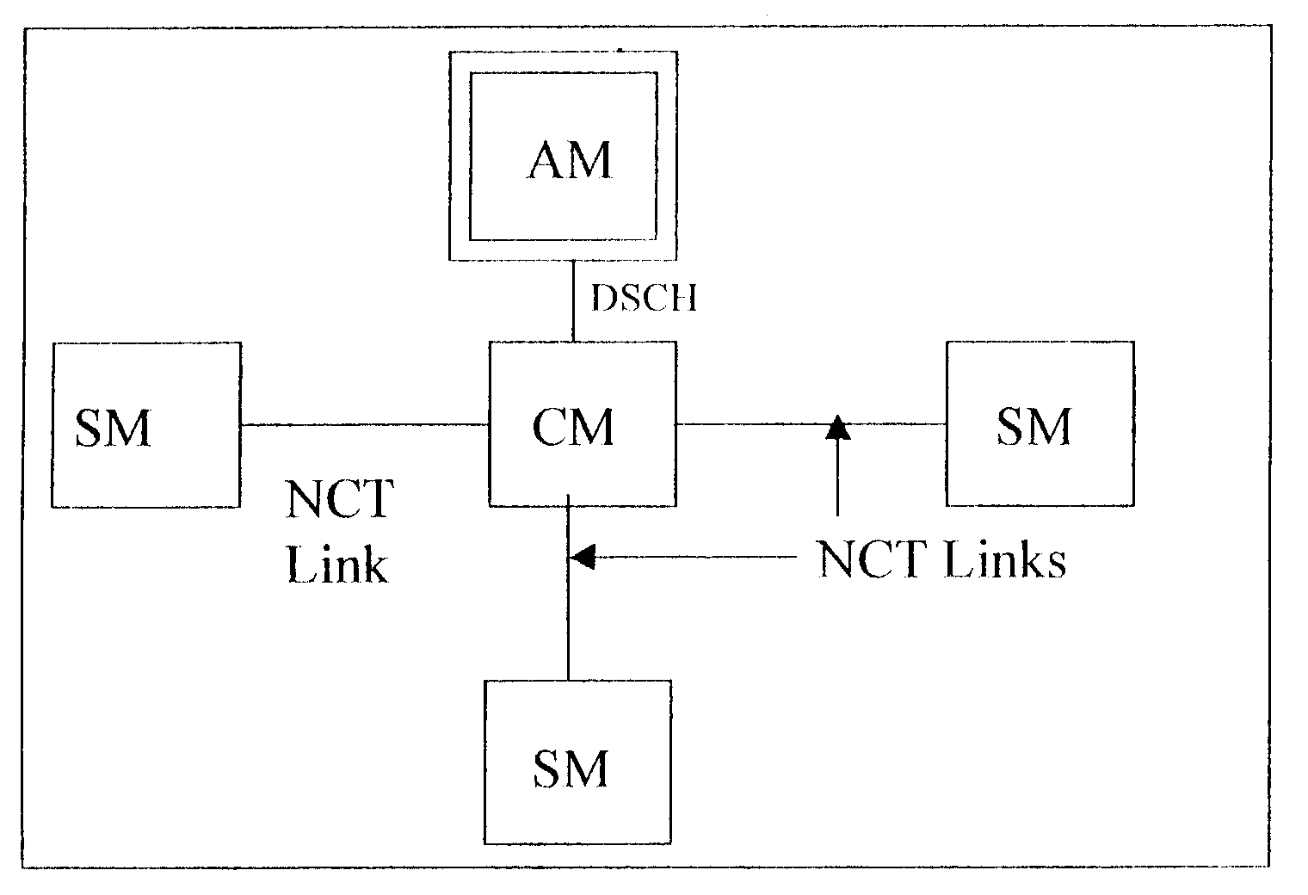
Modular Distributed Design
Figure
Different Modules of 5ESS Switch
The 5ESS-2000 Switch is digital switching system with distributed processing. Distributed processing means that multiple processors handle all call processing functions. Many processors are distributed throughout the system supported by a central processor. These distributed processors handle second-to-second decisions that must be made to process a call. Call processing, self-maintenance, and testing are performed independently in each module. Processors communicate with each other via an internal digital network that links the modules together.
The 5ESS-2000 Switch hardware is subdivided into three major types of equipment modules: the SM (Switching Module), the CM (Communications Module), and the AM (Administrative Module). Each module performs its assigned functions to contribute to the operation of the entire switch.
The SM connects all lines and trunks to the 5ESS-2000 Switch. It performs most of the call processing functions. There can be many SMs per 5ESS-2000 Switch.
The CM provides communication between the SMs and the AM. There is one CM per 5ESS-2000 Switch.
Growth and Degrowth
Modular architecture makes it easy to increase or decrease the capacity of the exchange. Increase in the capacity of the switch is called growth. Decrease in the capacity of the switch is termed degrowth. The SM is the primary module for growth or degrowth of the 5ESS-2000 Switching system. Growth or degrowth is accomplished by changing the number of SMs in a switch or the number or units within the SMs.
- SWITCHING MODULE
All external lines, trunks, and special services circuits are terminated at the switching module. The analog and digital signals are converted to the digital format used inside the 5ESS-2000 Switch. The SM performs almost 95% of the call processing and maintenance functions including:
- Line and trunk scanning
- Tone and cadence generation
- Digit analysis
- Call routing
- Circuit switching
- Packet switching
- Announcements
- Call progress supervision
- Routine maintenance and self-maintenance
The SM provides many subscriber calling features including:
- Call Waiting
- Abbreviated Dialing
- Call Diversion
- Conference Calls
One 5ESS-2000 Switch can support as many as 192 SMs. Each SM can handle as many as 5120 lines or 500 trunks, or a combination of the two. The SM-2000 can handle more than 65,000 lines and about 18,000 trunks. The maximum number of SM-2000s that can be supported by one switch is dependent upon engineering considerations.
2.1 Types of Switching Modules
A 5ESS-2000 Switch can be equipped with the following types of SMs.
- LSM (Local Switching Module): This type of SM serves local lines, and ISDN (Integrated Services Digital Network) users. The LSM is usually referred to as the SM.
- HSM (Host Switching Module): This type of SM provides the normal LSM subscriber interfaces and also interfaces one or more RSMs (Remote Switching Modules).
- RSM (Remote Switching Module): This type of SM is designed to meet the needs of those communities that are too small to be served by their own 5ESS-2000 Switch in a remote area. This is done by having the RSM connected to an HSM. This RSM can be as far away as 242 kilometers from the host. Up to 4 RSMs (called a MMRSM (Multi-Mod RSM) can be interconnected to serve 16,000 lines, 2,000 trunks, or a combination of line and trunks. The RSM provides full stand-alone capabilities, including direct trunks to other exchanges, and can be used singularly or grouped in clusters.
- PSM (Position Switching Module): This type of SM supports OSPS (Operator Services Position System) features.
Originally the SMs were called IMs (Interface Modules).
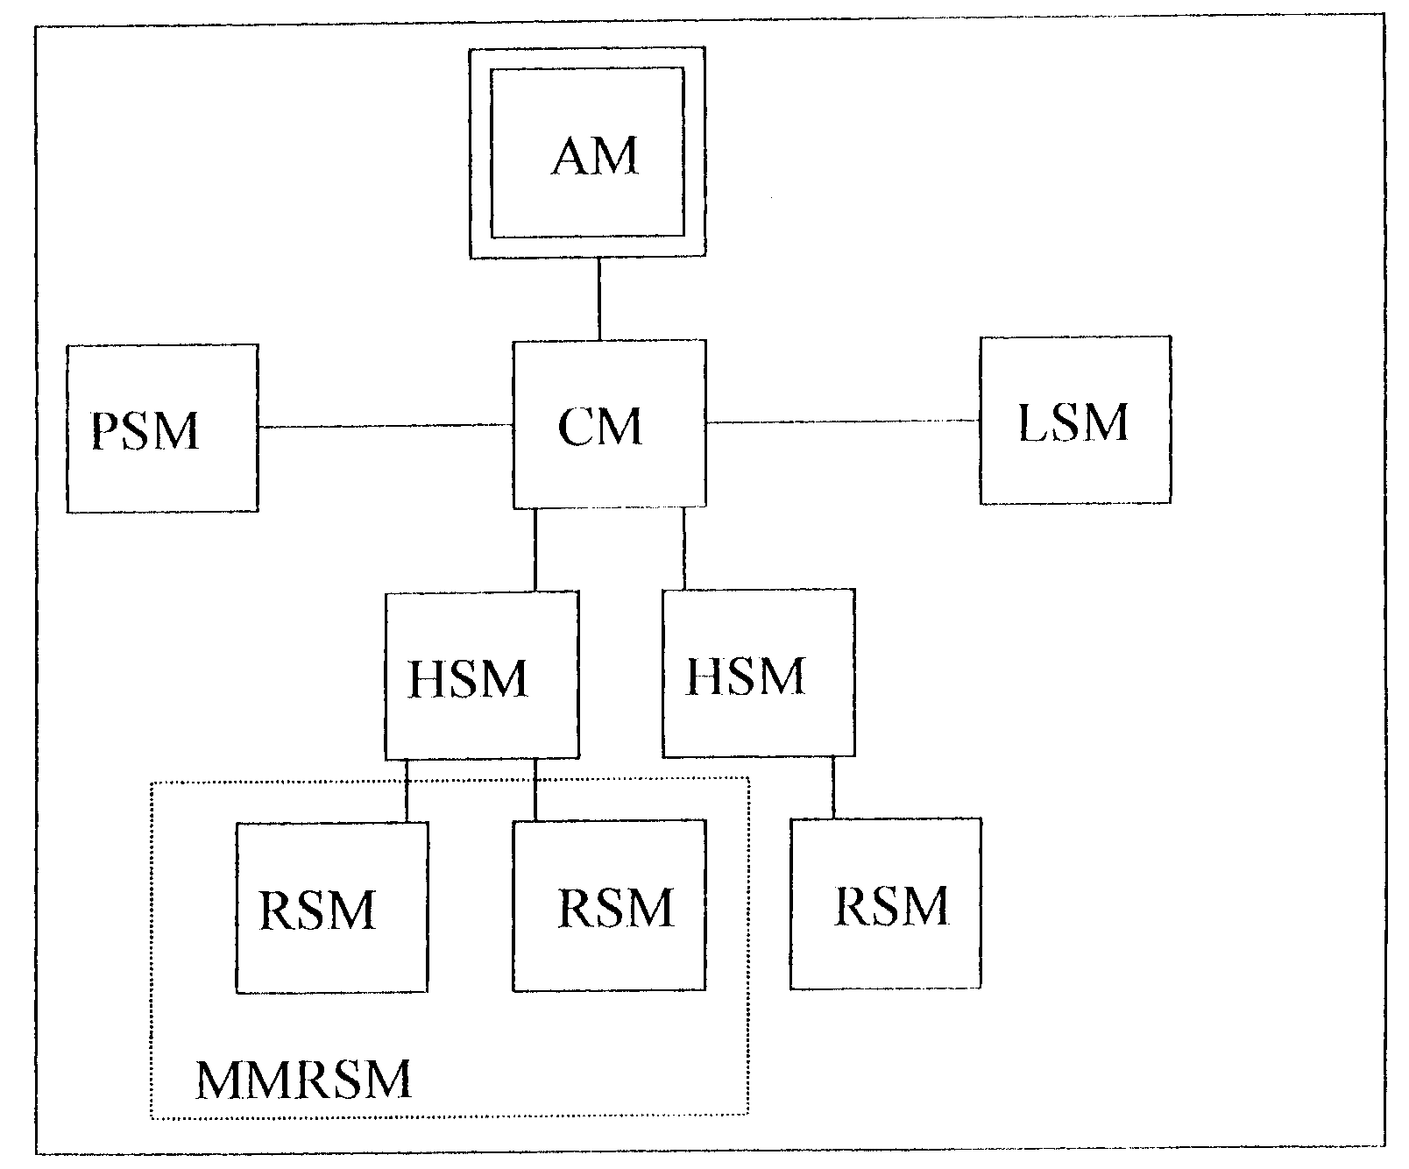
Occasionally on equipment and in documentation, you will see references to the IM. This is really a reference to the SM.
Figure
Types of Switching Module
  - Switching Module Components
An SM is comprised of two types of cabinets. The single SMC (Switching Module Controller) cabinet is numbered 1 and contains the control units that are assigned specific locations within the SMC.
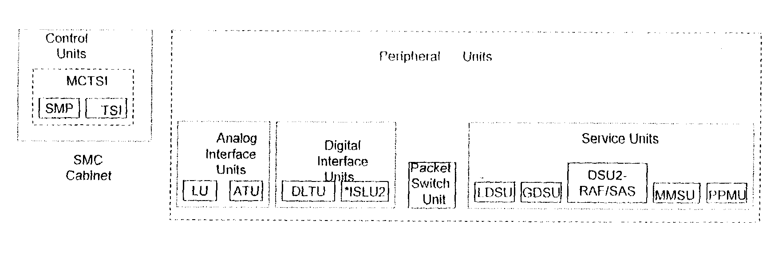
Figure
Switching Module Components
- Control Units - that control all activities within the SM, such as call processing and maintenance functions.
An SM can have from one to four LTP (Line/Trunk Peripheral) cabinets that are numbered 0, 2, 3 and 4.
- Peripheral Units - that perform testing functions and provide customers and other exchanges access to the 5ESS-2000 Switch digital network. There are two types of peripheral units.
- Interface Units - that interface packet data, analog and digital lines, and trunks to the 5ESS-2000 Switch.
- Service Units - that provides support as test equipment and multiport conferencing circuits.
The newer, more capacity SM-2000 cabinets are called the same (SMC and LTP) but are arranged quite differently. This will be discussed later in more detail. The numbering of the cabinets is important as diagnostic messages will indicate specific cabinets for trouble correcting procedures.

LPTO
SMC1
LTP2
LTP3
LTP4

Figure
Switching Module Cabinets
SM Control Units
Located in the SMC cabinets are the two SM control units, the SMP (Switching Module Processor) and the TSI (Time Slot Interchanger). These two units are combined into the MCTSI (Module Controller and Time Slot Interchange), which is also referred to as the MCTU.
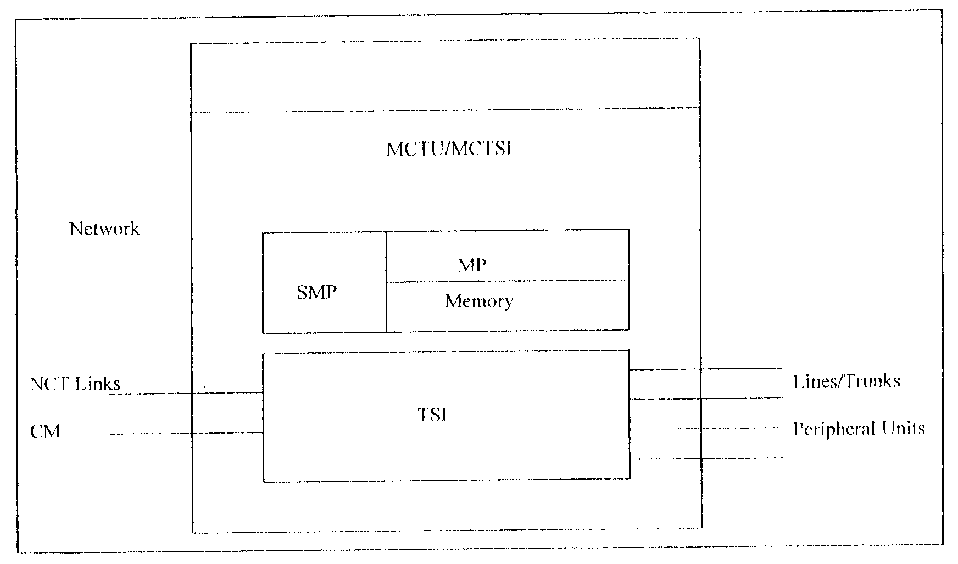
Figure
SMC Cabinet
Switching Module Processor
The SMP contains the microprocessor and memory used to perform the call processing and maintenance functions within the SM. The SMP performs five major functions:
- Controls peripheral units.
- Performs call processing.
- Performs SM maintenance.
- Initializes SM memory.
- Communicates with the AM and other SMs.
Time Slot Interchanger
The second control unit in the SM is the TSI (Time Slot Interchanger). The TSI performs the time portion of the time-space-time division switching. This type of switching allows multiple inputs access to a set number of outputs when processing phone calls.
The TSI transmits and receives peripheral time slots to and from peripheral units. Peripheral time slots contain digital call data from lines and trunks or other user data, such as from computers.
The TSI also switches data from the network side to the CM where it is routed to other SMs.
The TSI interchanges the peripheral time slots to the network time slots on two NCT (Network Control and Timing) links connecting the SM to the CM. In the reverse direction, the TSI also interchanges network time slots to peripheral time slots. The TSI also interchanges peripheral time slots between different peripheral units.
Note: There are various versions of the MCTU. Currently an SM can be equipped with an MCTU2/MCTU3 (Module Controller Time Slot Interchange Unit Model 2 or Model 3).
SM Peripheral Units
The SM peripheral units consists of the following:
- Interface Units.
- Packet Switch Unit.
- Service Units.
Interface Units
There are two analog interface units:
- LU (Line Unit) - connects analog lines from the subscribers’ telephones to the 5ESS-2000 Switch Digital Network.
- ATU (Analog Trunk Unit) - terminates a variety of analog trunks to the digital switching network. These voice frequency trunks can be interchange trunks, trunks to PBXs (Private Branch Exchange), trunks to announcement machine units, or local test circuits.
There are two digital interface units:
- ISLU2 (Integrated Services Line Unit Model 2) - terminates both digital and analog subscriber lines. The ISLU2 is equipped in SMs that have ISDN (Integrated Services Digital Network), and its primary purpose is to provide service to the ISDN subscribers.
- DLTU (Digital Line Trunk Unit) - terminates digital trunks from other exchanges or from RSM facilities in a switch and converts T1 or PCM (Pulse Code Modulation) 2Mb/s (Megabit per second) format to network time slot format.
Packet Switch Unit
The PSU (Packet Switch Unit) is a special interface unit that does not directly terminate lines or trunks. The PSU performs several miscellaneous ISDN functions:
- Processes ITU-T (International Telecommunication Union Telecommunication Standardization Sector) No. 6 and 7 signalling.
- Processes packet switched data.
Service Units/Service Circuits
There are five types of service units, three of which are referred to as DSUs (Digital Service Units). The different types are as follows:
● LDSU (Local Digital Service Unit)
The LDSU has the following two functions:
- To generate digital tones.
- To decode digital tones.
The tones generated or decoded by the LDSU can be routed to any line or trunk on a particular SM. The LDSU functionality can be provided in a variety of equipment configurations ranging from a full unit to a single circuit pack.
  GDSU (Global Digital Service Unit)
Every 5ESS-2000 Switch has at least one GDSU which can provide services to any SM in the exchange. The GDSU can also be configured in a variety of ways. The GDSU has the following two functions:
- Conference capabilities.
- Transmission testing.
    DSU2-RAF/SAS (Digital Service Unit 2 - Recorded Announcement Function/Service Announcement System)
The DSU2-RAF/SAS provides an announcement when a call is routed to a vacant code, equipment is busy, or blocking conditions exist. Other uses include OSPS features and when customized announcements are needed. SAS has more announcement capacity than its predecessor, RAF.
   MMSU (Modular Metallic Service Unit)
The MMSU, also referred to as MSU, provides the following three functions:
- Metallic test access.
- Subscriber line testing.
- A scan and distribute function.
   PPMU (Periodic Pulse Metering Unit)
Subscriber lines used in coinboxes, hotels and restaurants very often have a home meter installed. These subscribers are connected to the PPMU (or PPUM auxiliary), which injects the correct signalling to increment the home meter, and provides the subscriber with an accurate measure of phone usage.
- COMMUNICATION MODULE
Because of the distributed processing architecture of the 5ESS-2000 Switch, information must constantly be exchanged between processors. The CM (Communications Module) serves 5ESS-2000 Switch. This section describes the functions, linkages, and major components of the CM.
Communication Module Functions
In the switch, the AM and SMs are not directly connected to each other. The CM routes messages between each module so they all work together. The CM has four main functions:
- Call Switching: The CM interconnects the paths between switching modules to complete telephone calls and to relay data.
- Message Switching: The CM provides paths to send information between processors to process calls, maintain records, and perform system tasks.
- Network Timing: The CM provides accurate timing and synchronization for the 5ESS-2000 Switch.
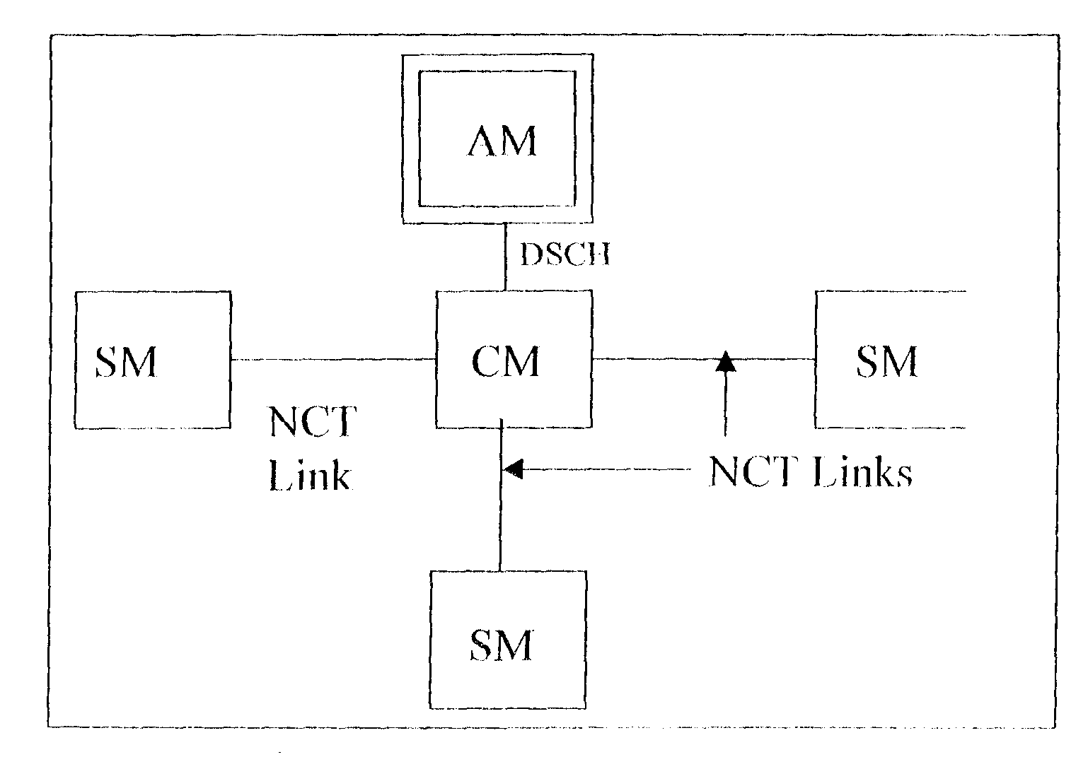
- Fast Pump: The CM provides resources to quickly download (pump) software, from the AM to ANSM if needed.
Figure
Communication Module Linkages
Communication Module LInkage
The AM is connected to the CM by the DSCH (Dual Serial Channel) bus. This metallic bus has two serial bit streams that receive and relay control messages.
NCT (Network Control and Timing) links are fibre optic cables that connect each SM to the CM. The NCT links carry information in a maximum of 512 time slots divided between two physical links. One of the 256 time slots.
Each of the control time slots is used to carry intermodule control messages. The other 255 time slots per link are used to carry call data (voice samples or customer data transmissions).
The CLNK (Communications Link) is the hardware path between the SMP (discussed in later lessons) and the MSPU (Message Switch Peripheral Unit) or the CM which is introduced in this lesson. This is the path that carries the control time slot. Because of the redundant nature of the CM hardware, each SM has alternate CLNK paths across the switching network.
3.1 CM Cabinet Configurations
The CM lineup can vary in size from a minimum of two to a maximum of twelve cabinets that are grown from the centre out in mirror image. Basic cabinets 5 and 6 are always equipped and depending on the number of SMs supported, additional cabinets can be added, two at a time, starting with growth cabinets 4 and 7.
0 | 1 | 2 | 3 | 4 | 5 | 6 | 7 | 8 | 9 | 10 | 11
Growth CM Cabinets Basic CM Growth CM Cabinets
Cabinets

Figure
CM Cabinets
Major Components of the CM
All versions of the CM are divided into two functional units: The MSGS (Message Switch), and the ONTC (Office Network and Timing Complex). The following description is based on the most common type of CM currently in the field, the CM2.
The MSGS and ONTC are each made up of subunits. The four major functions of the CM are performed by these hardware subunits:
- MSGS
- MSCU (Message Switch Control Unit).
- MSPU (Message Switch Peripheral Unit).
- ONTC
- CMCU (Communications Module Control Unit).
- TMSU (Time Multiplexed Switch Unit).
The ONTC also includes some functional areas of the SM/SM-2000.
MSCU
CMCU
TMSU
MSPU
MSGS
ONTC

Figure
CM Components
The MSCU provides control over the MSPU. If passes control information to and from the AM and the other CM units; it also interprets the destination code of the control messages flow between processors in the AM and the SMs.
The MSPU processes control messages and switches them to the AM or SMs. The MSPU can be regarded as a series of mail boxes in which messages are deposited before they are routed. Each SM has assigned capacity in the MSPU, and control messages are transferred under direction of the MSCU.
The CMCU provides timing for the system and provides control for the TMS (Time Multiplexed Switch). It also provides the connection path between the TMS and AM, MSCU and MSPU.
The TMSU terminates the NCT links and switches both data and control time slots between the links. The hardware units of the TMS perform the actual switching of the calls between trunks.
No single unit of the CM is more important than others. Because of the interconnecting paths, all the parts are necessary. Because of this, virtually all parts of the CM are duplicated.
  - Types of Communication Modules
There are four types of CMs in the field:
- CM1: This was the earliest type of CM. It operates much the same as the CM2 which was just described, but is of an older vintage. It is made up of a maximum of 4 cabinets of equipment. It is capacity-limited (32 SMs) and has been replaced nearly everywhere with CM2.
- CM2: Most common today, the CM2 can support up to 192 SMs, or a mix of SMs and SM-2000. It is made up of a minimum of 2 cabinets, but can grow to as many as 12 when needed.
- CM2 with QLPS (Quad Link Packet Switch): This is a modification of the CM2 which adds additional control message capacity. It is available for offices with high capacity SM-2000s. It is nearly identical to the CM2, with additional hardware units added.
- CM2C: This unit is intended for small office applications and supports only a limited number of SMs. It is made up of 2 shelves, which can reside in an SM cabinet.
- ADMINISTRATIVE MODULE
In the 5ESS-2000 Switch, the AM (Administrative Module) is a switch equipment module which has the overall control of the entire 5ESS-2000 Switch. The AM controls the CM and communicates with all the SMs (through the CM). The AM monitors itself and the CM for malfunctions. If there are any problems, they are reported to maintenance personnel.
4.1 Administrative Module Functions
The AM has a minimum of one cabinet and can have a maximum of three cabinets. The AM performs resources allocation and processing functions that are done more efficiently on a centralized basis such as:
- Call routing for intermodule and intramodule calls.
- Administrative data processing/billing data.
- Traffic measurement reports/system performance reports.
- Memory management.
- System maintenance.
- Maintaining file records of changes to the system Software Release.
- Personnel interface/system monitoring.
- Allocating trunks for call processing.
  - Administrative Module Components
There are three main units located within the AM :
- CU (Control Unit).
- IOP (Input/Output Processor).
- DFC (Disk File Controller).
The CU monitors overall system operation. The IOP interfaces with the MCC (Master Control Centre), ROP (Receive Only Printer) and other peripheral devices. The DFC controls the TD (Tape Drive) and Disk Drive (DD).
The Control Unit consists of: the CC (Central Control) and the MM (Main Memory) subunits.
- The CC has six major functions:
- Executes programs: the CC contains logic circuits that execute step-by-step instructions to control the operation of the AM processor.
- Executes program requests: responds to requests from the SM and from maintenance personnel.
- Processes administrative data: compiles report information and prints reports periodically.
- Monitors system operation: maintains a log of equipment status and a list of OOS (Out-Of-Service) equipment.
- Updates duplicate CU: communicates with duplicate standby CU to keep its memory up-to-date.
- Manages data transfer: controls memory transfer between its own memory, its hard disk, and the microprocessors that serve the peripheral units in the IOP.
- The MM stores program instructions and data. The MM stores the instructions and other data needed by the processor to process calls, collect administrative information, and perform system maintenance.
CU
CC
MM
DFC
TD
DD
IOP
MCC
ROP

CU

Figure
Administrative Module Components
  - AM Peripheral Component Functions
Disk File Controller
The DFC is responsible for interfacing with the SCSI (Small Computer System Interface) Peripheral Devices, such as the disk and tape drives.
SCSI Disk Drive
The functions of the SCSI (Small Computer System Interface) disk drive are as follows:
- Stores copies of software used in the 5ESS-2000 Switch - if data in the MM is lost, it is restored from the disk copy.
- Stores hardware configuration data - information on the disk defines the configuration of hardware, and line and trunk terminations.
- Stores billing data - disk has a temporary area for billing data. The data is stored until it is requested by the host collector or dumped to tape.
Tape Drive
The tape drive is a backup for information stored on disk. The tape drive may be either a conventional computer nine track tape drive or a DAT (Digital Audio Tape). Data can be transferred from tape to disk or from disk to tape. Billing data for the Revenue Accounting Office is also stored on tape.
Input/Output Processor
The IOP is the interface for other peripheral devices used by the switch, such as maintenance interfaces (MCC and ROP), datalinks and alarm signalling.
Master Control Centre
The AM maintains up-to-date records on system operations and knows the status of all hardware units throughout the exchange. This information is available to maintenance personnel through the human/maintenance interface the MCC (Master Control Centre). The MCC is the main local workstation for maintenance personnel. It uses a full-colour video display terminal as a window to the system. By entering poke commands selected from menus on the terminal screen or man machine language commands selected from the 5ESS-2000 Switch Commands and Reports Manual, maintenance personnel can diagnose equipment, remove equipment from service, restore equipment to service, test lines and trunks, and modify the database and service features for customers. The ROP (Receive-Only Printer) provides a printed copy of reports from the MCC.
The primary functions of the MCC are to provide the following:
- Visual displays of system status and alarm information.
- The means to control, test and reconfigure the system.
- The means to manually recover the system.
- Access to exchange data.
5.0 CALL PROCESSING
There are five functional steps of call processing, including the location of the originating and terminating equipment. These steps are :
- Origination: Origination begins when the subscribers line goes off-hook or when an incoming trunk is seized. Origination receives the incoming digits, selects the digit analysis tables, and determines the screening information for this call.
- Digit Analysis: Digit analysis interprets the digits that it receives from origination, selects a destination for each call, and passes the dialled digits to routing.
- Routing/Screening: Routing uses the destination information form digit analysis and screening information form origination to select the terminating trunk group or line. The type of charges associated with this call is determined and sent to charging.
- Charging: Charging uses the charging information form routing to expand the charging data into a format useable by the Call Accounting process. There are various types of call accounting features; form basic AMA records to Fee Calculation.
Subscriber Line
or
Incoming Trunk
Origination
Digital Analysis
Routing/Screening
Charging
Termination
Subscriber Line
or
Outgoing Trunk
Figure
Call Processing Stages
- Termination: The last step in call processing is termination. Termination process are different for calls destined for lines and calls destined for trunks.
- Trunk Termination: An idle trunk member of the trunk group is selected based on a predetermined pattern. After selection, digits are outpulsed to the distant office.
- Line Termination: The line identified in routing is checked to determine if the line has any special features. Ringing is applied to the line if applicable or the special feature is activated.
Call Processing
The most important function of a 5ESS-2000 Switch is to process subscriber calls. Subscriber’s calls can be classified as line-to-line, line-to-trunk, trunk-to-line, or trunk-to-trunk. A line-to-line call is a call that starts on a line served by a 5ESS-2000 Switch and terminates to another line served by the same switch. The SMs involved in the call will perform almost 95 percent of the call processing functions.
During a line-to-line call, the originating SM detects when a subscriber’s telephone receiver has been picked up. The SM provides dial tone and then removes dial tone when the first digit is dialled. It then collects and analyzes the dialled digits. Next, the SM sends a request to the AM for a call path. The terminating SM locates the subscriber line for the line-to-line call and provides ringing.
Basic Call Types
Origination | Termination
Line | Line
Line | Trunk
Trunk | Line
Trunk | Trunk
When the AM has selected and available path, it alerts the CM to set-up a link between the SMs.
The CM provides call paths between SMs and carries all internal system communications.
The functions of the SM, AM and CM in a trunk-to-trunk call are basically the same as the line-to-line call described above except that the originating SM detects a trunk seizure rather than a subscriber picking up the receiver. Also, the terminating SM locates an available trunk instead of a line.
If a call involves both a line and a trunk (line-to-trunk, trunk-to-line), the scenarios above may differ slightly. Also, the scenarios may differ depending on the applications supported by your exchange.
Line-To-Line calls can be of two types:
- INTRA-SM – where both subscriber lines (originated and terminated) are connected to same SM. This doesn’t require use of CM.
- INTER-SM – where both subscriber lines are connected to different SMs. This requires use of CM.
6.0 5ESS-2000 SWITCH APPLICATIONS
The 5ESS-2000 Switch was designed with a flexible modular approach with regard to both software and hardware, allowing for digital services, and capabilities that support many applications. Current applications supported by the system are as follows:
- Local exchange.
- Toll exchange.
- Gateway exchange.
- OSPS (Operator Service Position System).
- ISDN (Integrated Services Digital Network).
- STP (Signalling Transfer Point).
- SSP (Services Switching Point or Action Control Point).
- MSC (Mobile Switching Centre or Wireless).
Local Exchange
Local subscribers gain access to the local exchange through lines. The exchange switches a call from an internal subscriber to another subscriber directly or through a trunk circuit to a subscriber in another exchange. A trunk circuit (or trunk) connects a local exchange to another local exchange or toll exchange. A local exchange has high percentage of lines and a small percentage of trunks.
Toll Exchange
A toll exchange (or trunk tandem exchange) connects a local exchange to another local exchange or to a gateway exchange. A toll exchange has a high percentage of trunks and a low percentage of lines, if any.
Gateway Exchange
There is one international network consisting of interconnected gateway exchanges. Each country (A and B) in this network has its own gateway exchange, an international toll exchange. International calls enter and leave the country from this gateway exchange.
Local
GW_{B}
GW_{A}
Local
Toll

Figure
5ESS Switch Applications
Operator Service Position System
The 5ESS-2000 Switch offers automatic operator services via the OSPS (Operator Service Position System). OSPS applications are Directory Inquiry to supply directory number to calling subscribers. Traffic Assistance allows operators to complete calls and respond to inquiries for subscribers. The OSPS uses a special SM called a PSM (Position Switching Module).
Integrated Services Digital Network
Another type of 5ESS-2000 Switch application is the ISDN (Integrated Services Digital Network). ISDN offers new voice and data services, and allows features such as OSPS. ISDN also allows voice, data and signalling information to travel over the same digital subscriber line. It lets all three components use the same transmission path simultaneously.
Two people with ISDN can make phone calls and use their computer terminals to access one or more computers at the same time. ISDN service is fully compatible with POTS service. ISDN service requires specific ISDN hardware and software in the SM.
Signalling Transfer Point
The STP (Signalling Transfer Point) is an exchange application that sends signalling messages on their way to the proper destination over a different path than the associated voice circuit. STPs are associated with the CCS7 (Common Channel Signalling 7) network. This application allows for more efficient use of trunk circuits.
Signal
Signal
Signal
Transfer
Point
Local/Toll
Voice
Local/Toll/Gateway

Figure
5ESS as Signalling Transfer Point
Service Switching Point
The SSP (Service Switching Point), also called ACP (Action Control Point), is a 5ESS-2000 Switch application that is part of an IN (Intelligent Network) configuration. IN technology allows the introduction of advanced services, primarily through software updates, with minimal network rearrangements and minimal service disruption. The SSP is able to recognize and incoming IN call, process it, or request call handling instructions by use of a remote database that is accessed by many switches in the IN.
Mobile Switching Centre
The MSC (Mobile Switching Centre) performs the switching functions for wireless systems. This 5ESS-2000 Switch application monitors subscriber mobility, manages resources, communicates with other networks, performs call routing and control functions. The MSC configuration includes an AM, CM, SMs, WGSM (Wireless Global Switching Module), at least one WSM (Wireless Switching Module), and possibly a WRSM (Wireless Remote Switching Module) or multimodule.
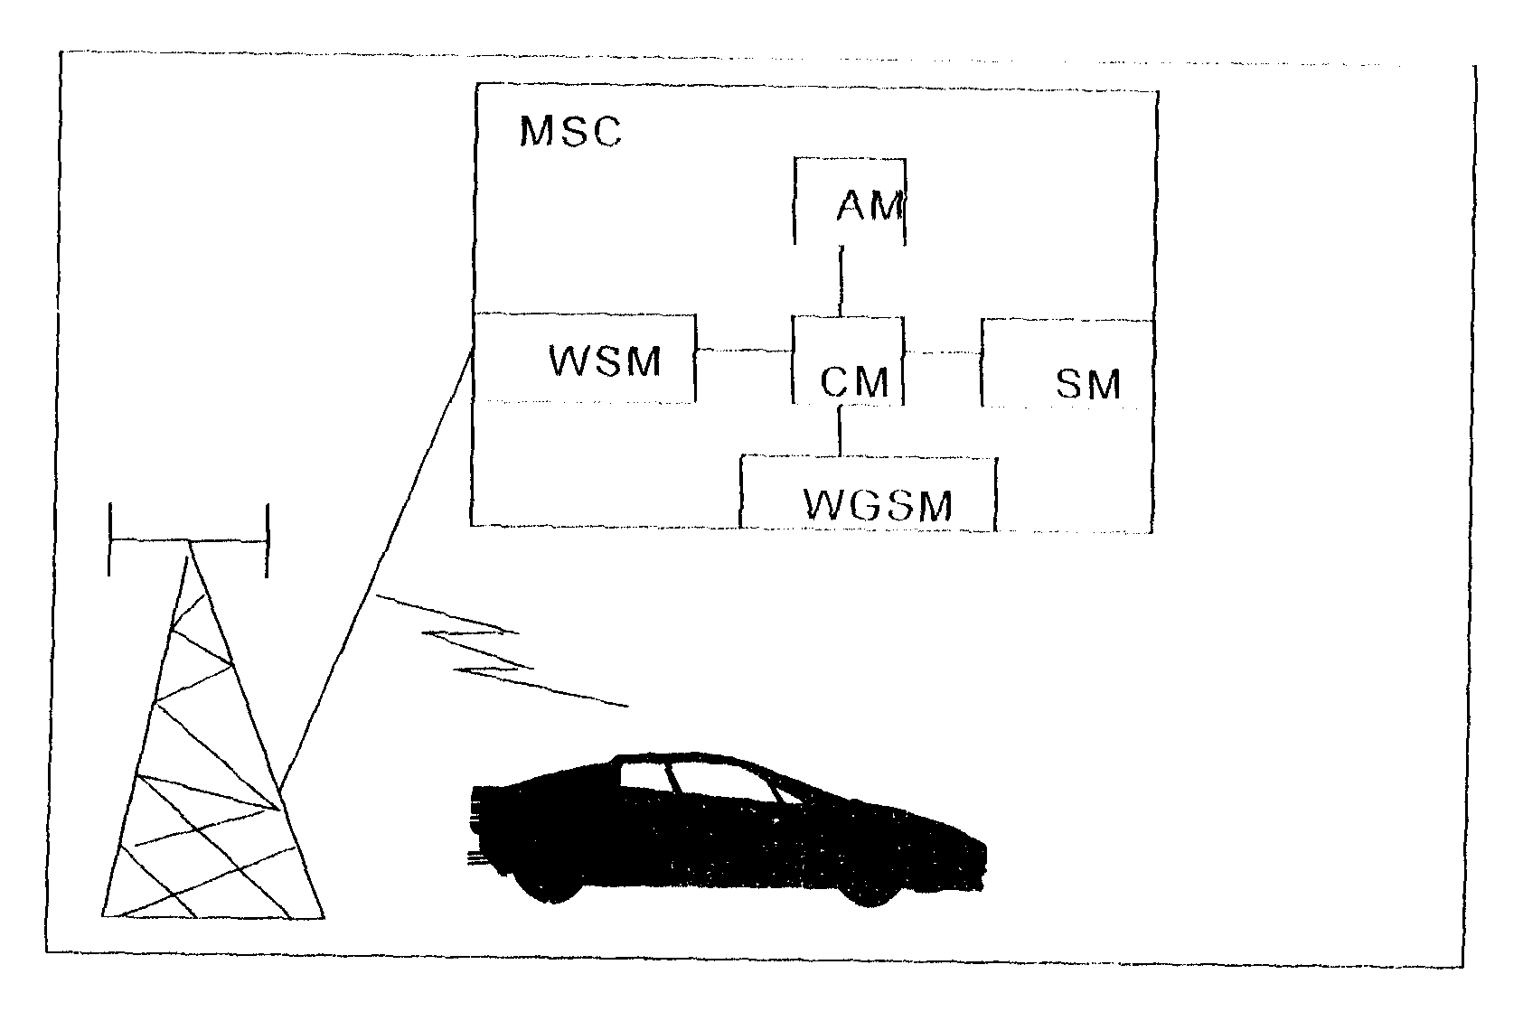
AM
WSM
SM
WGSM
CM
MSC

Figure
5ESS As Mobile Switching Centre
7.0 Maintenance Tools
The MCC (Master Control Centre), customer documentation, TLWS (Trunk and Line Workstation) function, and RC/V (Recent Change and Verify) function are all essential maintenance tools of 5ESS.
Master Control Centre
The MCC is the primary communication link between maintenance personnel and the 5ESS-2000 Switch of performing the maintenance functions. In smaller exchanges, it is possible to have only the MCC terminal. Larger exchanges will need more terminals and printers.
The primary MCC functions are to provide the following:
- Visual displays of system status and alarm information.
- The means to control, test and reconfigure the system.
- The means to manually recover the system.
- Access to Exchange data.
The MCC consists of the following components:
- TAU (Test Access Unit): Used to make certain trunk and line tests. It contains jacks for connecting portable test equipment such as voltmeters to the trunk and line circuits.
- Speakerphone: Used to communicate with other work locations or other exchanges.
- ROP (Receive-Only Printer): Provides paper copies of reports.
- Video Display Terminal with Keyboard: Used most often to communicate with the system. The video terminal displays commands and reports (input/output) and the keyboard provides a means of entering requests and commands to the system.
- Office Alarm Unit (not shown in figure): Notifies you problems in the switch with visual and audible alarms.
Trunk and Line Workstation
The function of the TLWS is to test the lines and trunks in an exchange. This function may be invoked from terminals located within the exchange (MCC) or from remote maintenance facilities.
The term TLWS can be used to reference the TLWS function (software) or the terminal used to access the TLWS function (hardware). A terminal is defined for use as a TLWS in the switch’s ECD database.
TLWS Function
The TLWS function is used to:
- Remove and restore service to subscriber lines and trunks for testing.
- Test subscriber lines.
- Initiate operational and transmission tests on trunks.
- Operational tests check the ability of a trunk to complete a call.
- Transmission tests measure the quality of signals being reserved by a trunk.
TLWS Terminals
The TLWS need only be a VDT (Video Display Terminal) and keyboard, although it may be equipped with the same equipment as the MCC. The basic TLWS equipment allows you to enter the TLWS commands and receive the test results. The input data, circuit information, and results are displayed on the VDT.
The TLWS function can be initiated from following terminals:
- MCC (Master Control Centre): This is the primary terminal for the TLWS function. All TLWS functions can be performed from this terminal.
- OMC (Operations and Maintenance Centre): This is a remote maintenance facility that can usually perform maintenance for several exchanges.
- STLWS (Supplementary Trunk and Line Workstation): Many exchanges than the MCC where the TLWS function can be initiated. These terminals are the STLWS terminals.
Since the MCC is usually used for controlling the exchange (initializations, etc.), most exchanges equip several STLWSs and use these for line and trunk testing instead of using the MCC as the main TLWS terminal.
Beltline Circuit
Sometimes tests are performed from locations other than the MCC. For instance, during installation, difficult fault conditions might occur in the SM (Switching Module), that can be located at a distance from the MCC. This may cause some inconvenience for maintenance personnel, since they must walk back and forth between the SM and the MCC. To avoid that, the 5ESS-2000 Switch frames (cabinets) are equipped with connectors to allow the maintenance personnel to connect portable I/O devices, such as a TTY or a terminal with keyboard near the SM. This feature is called the beltline circuit. Beltline jacks (connectors) are multipled at optional frame locations around the exchange making the circuit accessible from several points. They are mounted on a jack strip located between the fuse panels at the top of the equipment frames. Although the beltline jacks can be multipled to each SM, a maximum of two beltline circuits may be used at the same time. They are referred to as Beltline A and Beltline B. The beltline jacks are wired to the peripheral controllers in the IOP (Input/Output Processor) unit.

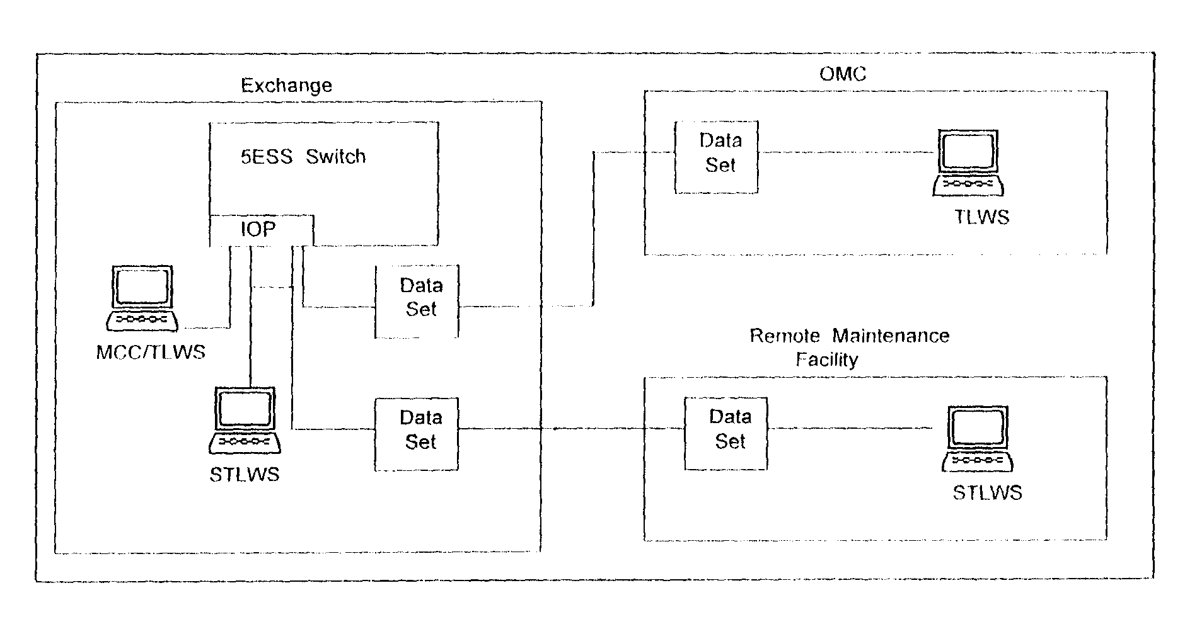
Figure
Maintenance of 5ESS
Recent Change and Verify
The RC/V (Recent Change and Verify) function enables you to view and alter the 5ESS-2000 Switch databases, and is accessed from the MCC (Master Control Centre), OMC (Operation and Maintenance Centre), STLWS (Supplementary Trunk and Line Workstations), or from optionally equipped RC/V terminals. The MCC and the OMC have access to all RC/V functions. Individual terminals, however, may be restricted to specific functions.
RC/V provides the capability to view and alter the databases in the 5ESS-2000 Switch.
The RC/V function has the following two modes:
- RC (Recent Change) mode provides a way of accessing and changing the system databases to reflect changes in customer services or system capabilities.
- V (Verify) mode provides the ability to view, but both change, database contents. This allows one to verify that the correct changes were made.
Database forms, called views, can be output on the video screen and/or printed out on the ROP (Receive-Only Printer). Paper copies of the database forms can be saved and used as Office Records.
The three databases that are maintained in the 5ESS-2000 Switch are as follows:
- ECD (Equipment Configuration Database).
- SG (System Generation Database).
- ODD (Office Dependent Database).
The ECD contains data that defines the physical and logical configuration of the AM processor as it applies to the 5ESS-2000 Switch.
The SG database contains boot information and defines the disk layout in the AM processor. The system uses this database only during initializations.
The ODD database contains specific data used to define the switching characteristics and customer information for a particular 5ESS-2000 Switch. Administrative and maintenance personnel access the ODD on a routine basis to verify or update switching or customer information.
Customer Documentation
Customer documentation is categorized into the following four types:
- Descriptive Documents: Provides explanations of all available documents, introductions to the 5ESS-2000 Switch and its functions, and explanations of the system software and hardware. These documents are supported by illustrations, tabulated information, and drawings. Refer to these documents for background information on the 5ESS-2000 Switch or clarifications of terms used in procedural documents.
- Procedural Documents: Instructions executed sequentially to do such tasks as operations and maintenance procedures, recent change, hardware change, software retrofit, and software update. The instructions are written so that the objective can be accomplished by both experienced and non-experienced personnel. When additional data is required, this type of document also includes non-procedural information.
- Reference Documents: Provides reference information that can be used for clearing faults above the circuit pack level. Reference documents can be hardware related (to solve faults related to the cabling and backplane wiring) or software related (to solve problems such as programming errors or database errors).
- Site-dependent Documents: Contains information unique to a particular exchange, such as floor layouts, rack layouts, or cable listings.
8.0 SUMMARY
The 5ESS-2000 Switch uses distributed (or many) processors. In the switch, its modular design features a CM, AM and one or more SM s with the growth/ degrowth (Addition/Removal of equipment within the module) of SMs serving as the mode for changing the capacity of the exchange.
Switching Module has following components:
- Control units.
- Peripheral interface units including the packet switch unit.
- Peripheral service units.
Control units provide the following:
- Call processing.
- SM diagnostics.
- Quickly reinitialized RAM (Random Access Memory).
- Time division switching.
Interface units provide the following:
- Terminations for analog and digital lines.
- Terminations for analog and digital trunks.
- Packet switching.
Service unit provide the following:
- Tone generation and decoding.
- Conferencing and transmission testing.
- Announcements.
- Metallic line and trunk test.
- Metering.
The duplicated CM cabinet lineup is comprised of a minimum of two cabinets (Basic 5 and 6) and a maximum of twelve cabinets (Basic 5 and 6 and growth 0-4 and 7-11), that are grown from the centre out.
The major functions of the CM are call switching, message switching, network timing, and normal pump. The CM is linked to the AM with a DSCH bus (metallic), to the SM with NCT links (fibre optic cables), and from its MSPU to the SMP with a CLNK. The types of CMs are CM1, CM2, CM2 with Quad Link Packet Switch, and CM2C. The major components of the CM and their functions are:
- MSGS
- MSCU: Provides control over the MSPU.
- MSPU: Processes control time slots.

- TMS
- CMCU: Provides timing and control.
- TMSU: Terminates NCT links and switches data and control time slots between them.
The AM performs resource allocation and processing functions best performed in a centralized manner and provides overall control of the exchange.
AM has the following major components:
- Control Unit.
- Input/Output Processor.
- Disk File Controller.
The Control Unit consists of the following subunits:
- Central Control.
- Main Memory.
The IOP controls data transfer between the AM and external devices.
- The MCC is the local workstation or window to the system.
- The ROP records system output.
The DFC controls the disk and tape drives.
The Disk Drive stores the following:
- Copies of software.
- Hardware configuration data.
- Billing data.
The Tape Drive backs up the software release, exchange data and billing data.
The 5ESS-2000 Switch supports the following applications:
- Local exchange.
- Toll exchange.
- Gateway exchange.
- OSPS (Operator Service Position System).
- ISDN (Integrated Services Digital Network).
- STP (Signalling Transfer Point).
- SSP (Services Switching Point or Action Control Point).
- MSC (Mobile Switching Centre or Wireless).
The MCC, TLWS, RC/V, customer documentation and beltline circuit are tools essential for switch maintenance.

